Insert in Binary Search Tree.
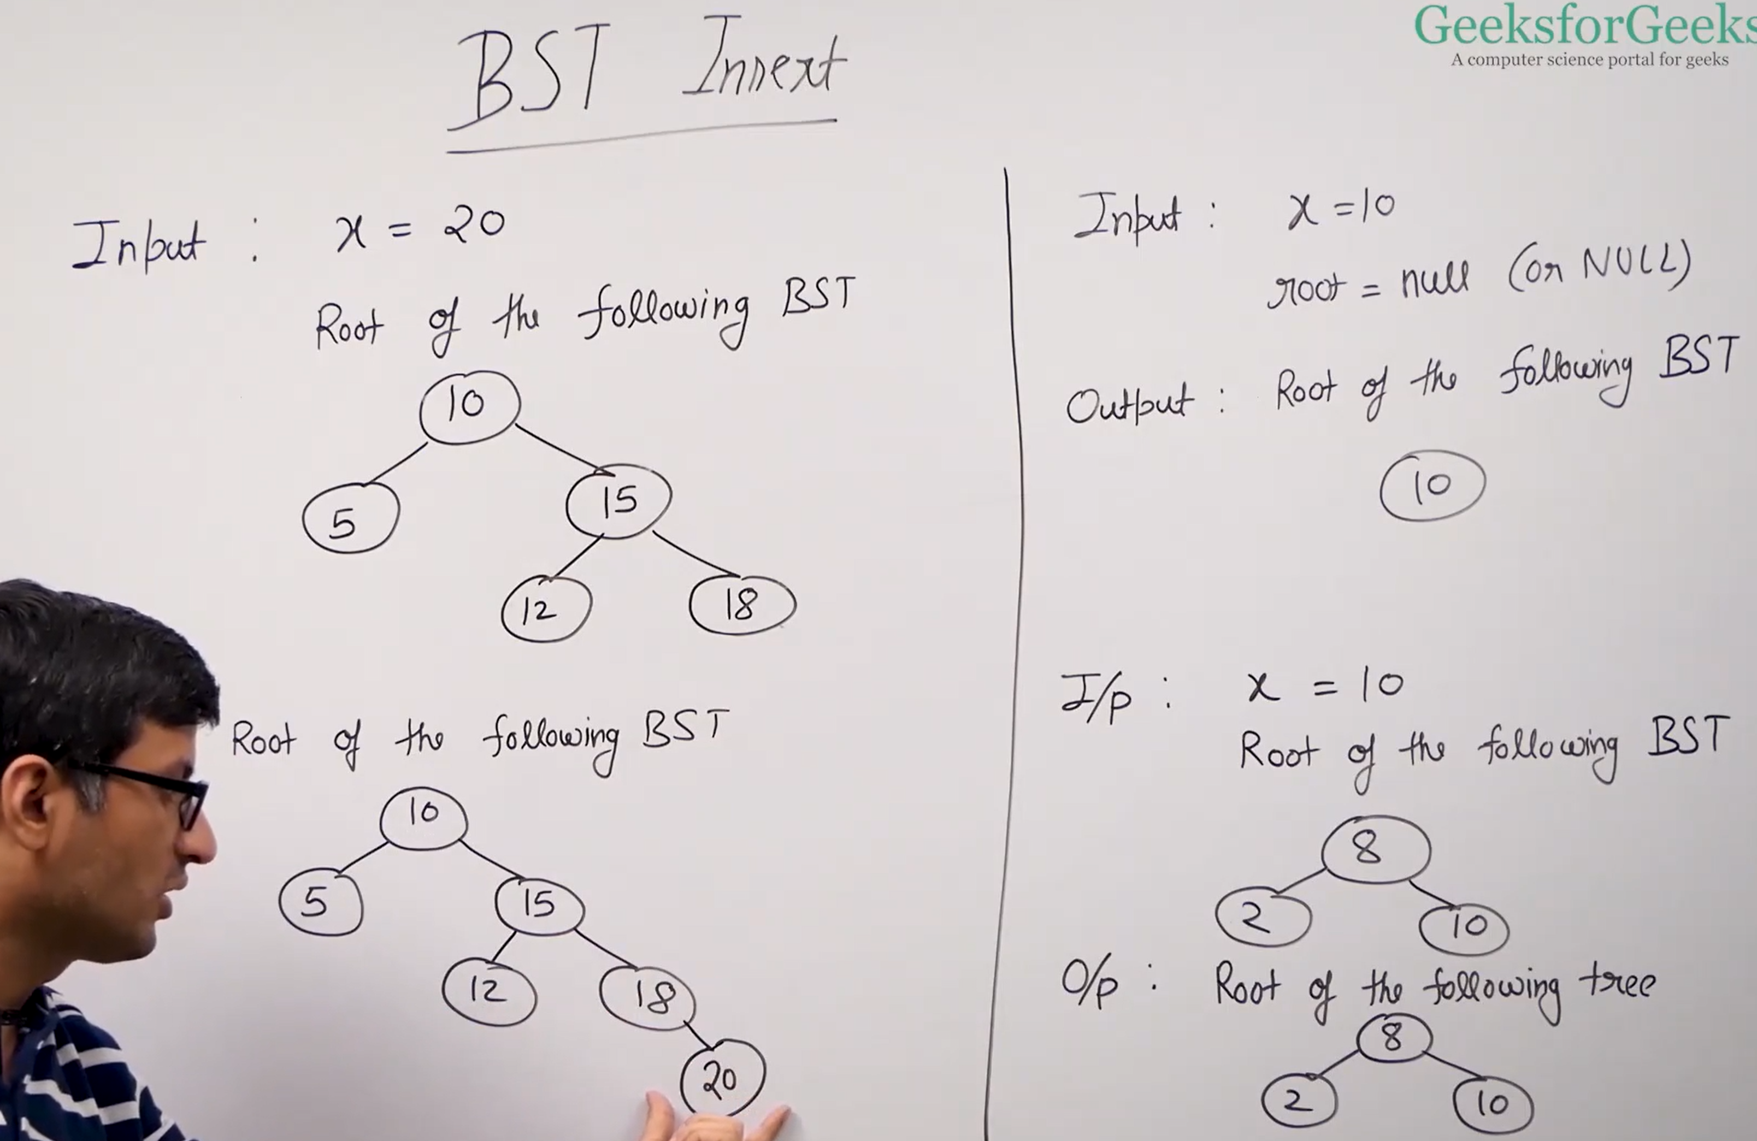
If we insert the node, then we can insert it at the last.
If the root is null, then only the root will change otherwise it won’t change.
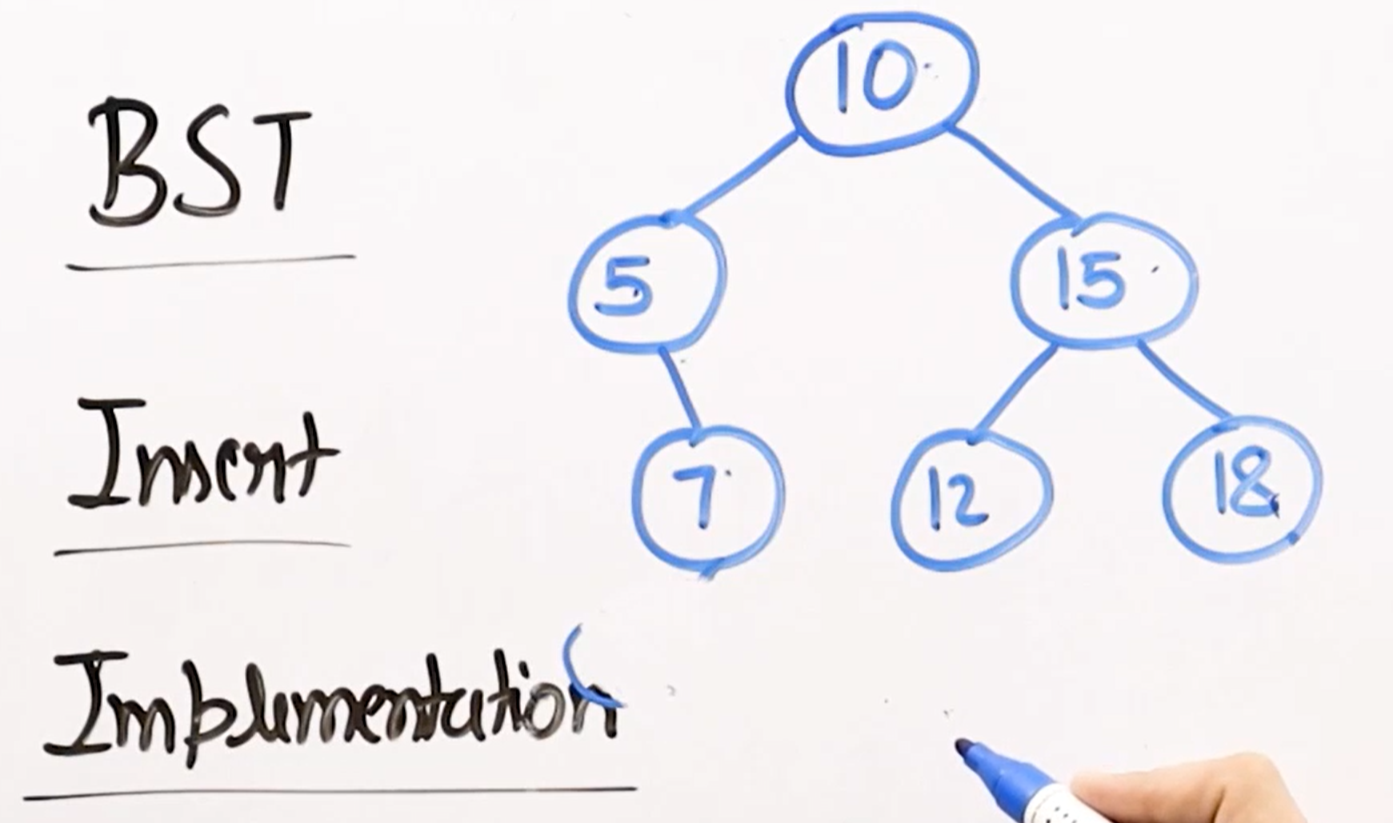
Recursive Approach.
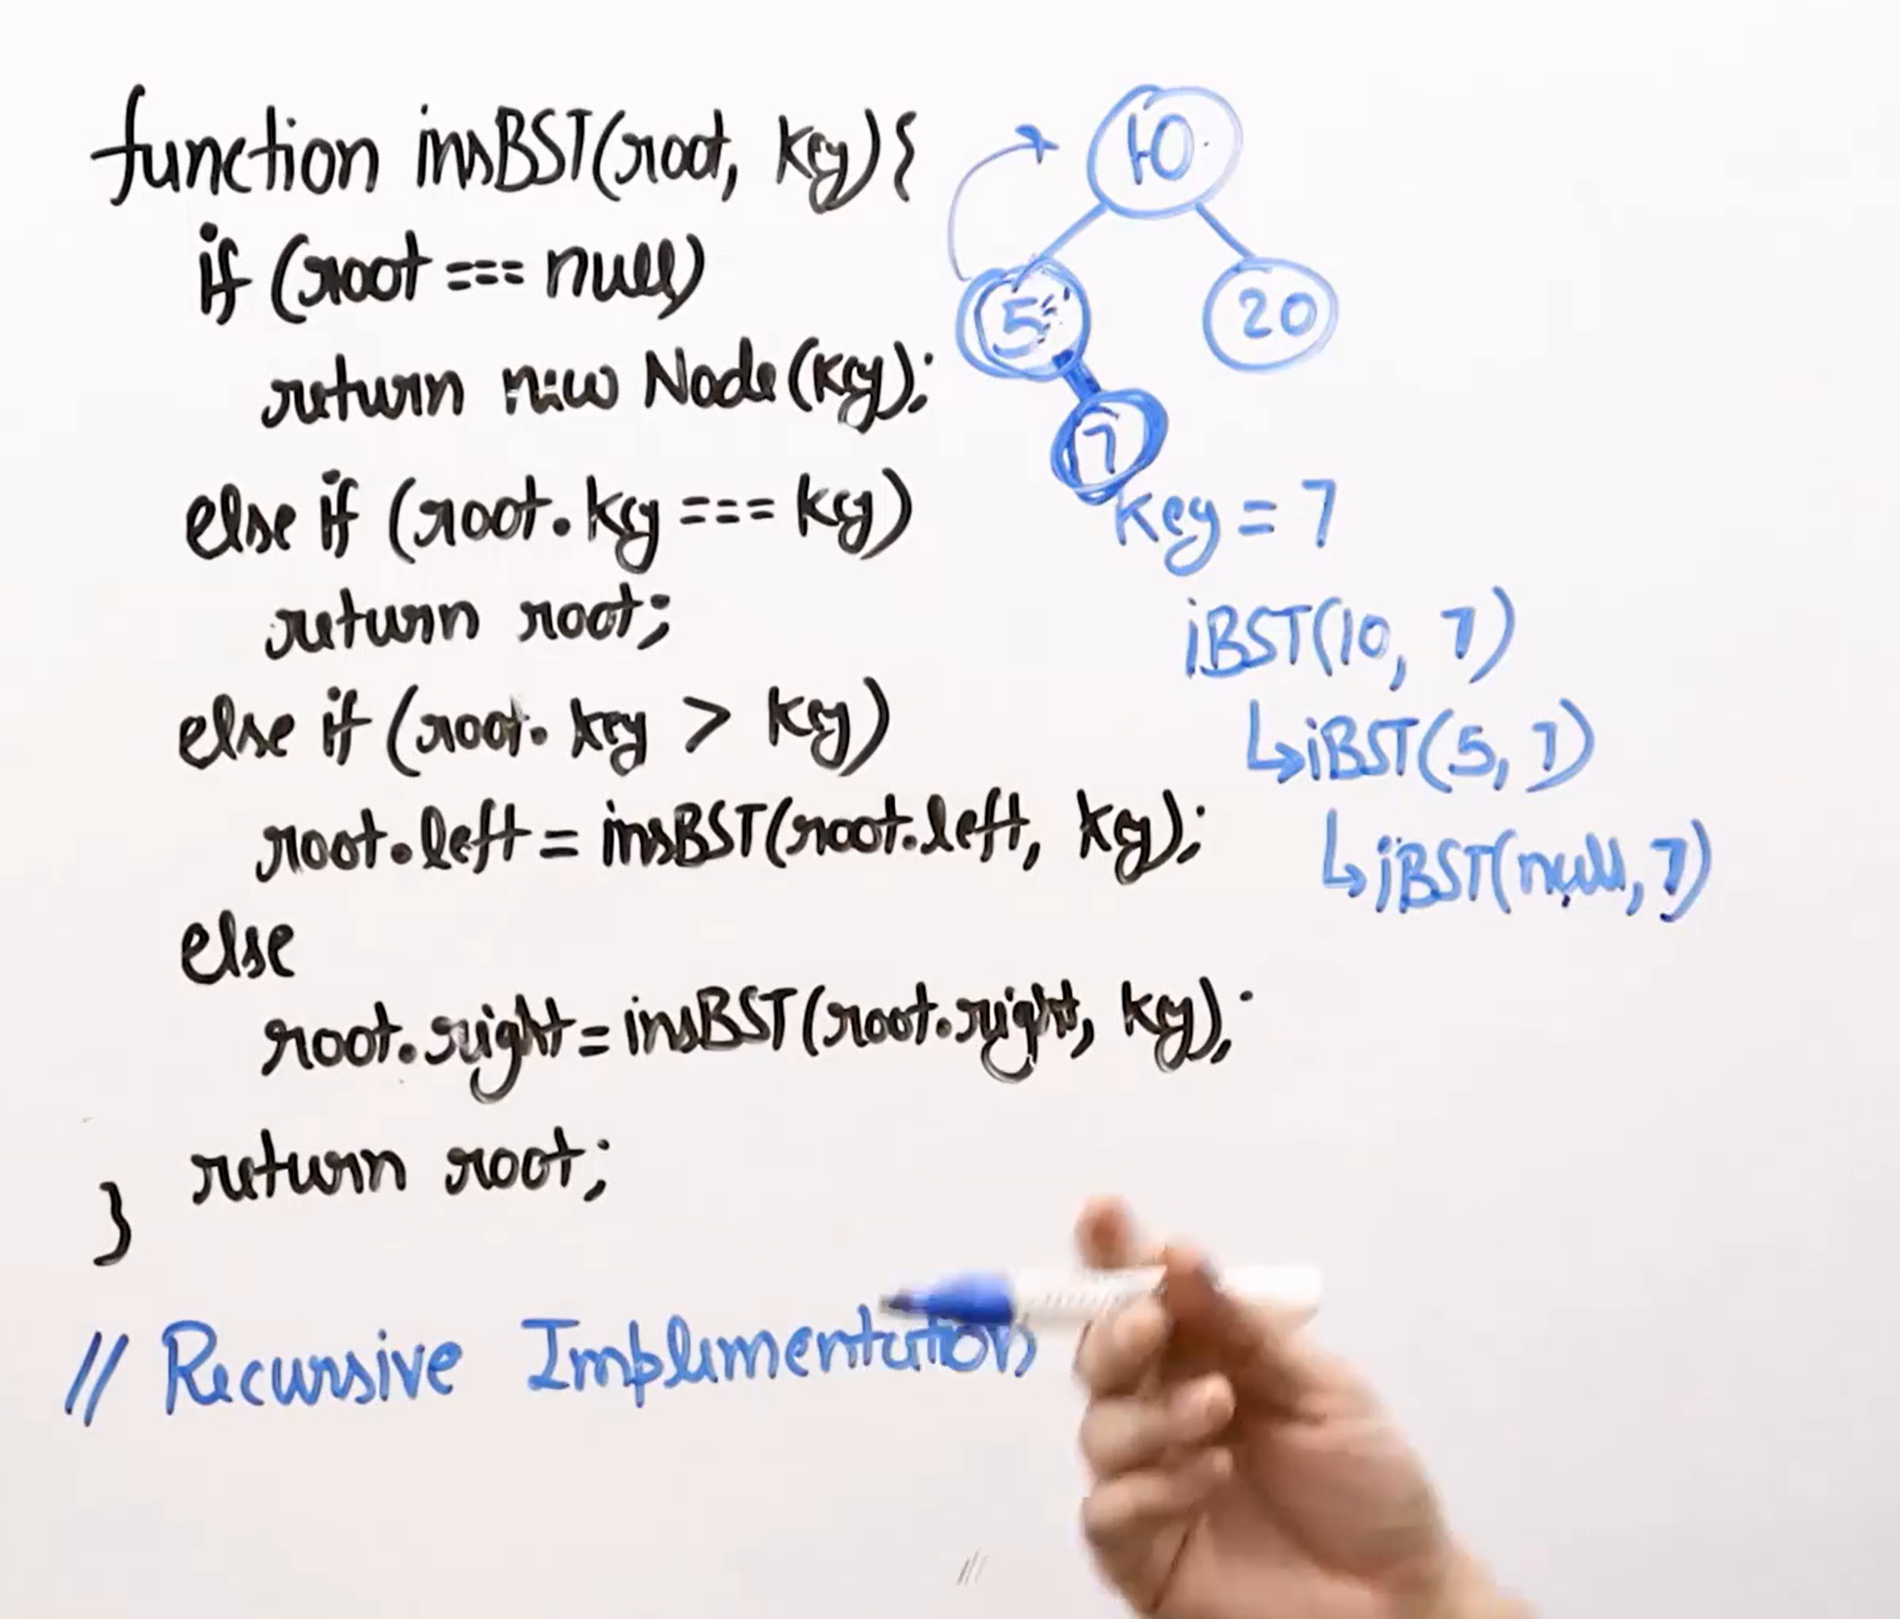

Iterative Approach.


